Title
Middle-aged male with interdigitating dendritic cells sarcoma

Authors

Abstract
Interdigitating dendritic cell sarcoma is a very rare to be seen in clinical practice. Since there is a limited number of publications in the literature, no consensus regards the best approach to manage such patient patients has been reached. With this case report, we present a case with advanced disease, and how our team faced the challenge of diagnosing and treating him.

Introduction
Interdigitating dendritic cell sarcoma (IDCS) is a very rare malignancy which originates from interdigitating antigen presenting reticular, dendritic, cells which commonly present in T-cell rich areas of the lymph nodes. [1-3] Clinically, it usually appears as painless Cervical, mediastinal and axillary, however, extra-nodal involvement especially spleen, liver and testis have been reported in nearly 30% of the cases. [3, 5-7] Bone marrow involvement is rare to be seen.[8]
The most two major obstacle which physicians face are; the process of diagnosis the disease and the heterogeneity of the case reports with regard the management. Approximately, there are less than 80 case reports along the entire literature. [1, 3]. The median age of diagnosis is between 50 – 60 years of age. [3, 4]
Histopathologically, this tumour arises from the subcortical zone in the lymph nodes in form of malignant cells with large eosinophilic cytoplasm and polygonal, spindle shape forming whorls. The malignant cells are usually surrounded by dense inflammatory reaction composed of T-lymphocytes, histiocytes and plasma cells embedded in hyalinized background. [3, 8] Other feature such as areas of necrosis or multinucleated giant cells might be present. [9] The hallmark immunophenotypic patterns are CD68 and S100 positive like the Langerhans cells while CD21 and CD 23 are negative excluding the follicular dendritic cell entity. [8, 10] In addition to that, the mitotic rare are usually moderate to high. [9]
There are several pathological obstacles that hinder the rapid and correct diagnosis of dendritic cell neoplasms including IDCS; no standard consensus among the best approach in diagnosis of these rare neoplasms, these neoplasms might simulate other forms of lymphoma with giant cells mimicking Reed-Sternberg ones, or form chronic granuloma-like reaction that might debate the diagnosis of malignancy. [11, 12] Thus, a preliminary diagnosis of the disease as lymphoma, malignant fibrous histiocytosis and chronic non-caseating granuloma are very common. [10-12]
IDCS is usually characterized by aggressive, poor responsive behaviour to chemotherapeutic agents with poor rates of relapse and survival. Till now, no chemotherapeutic regimen has been identified as a standard of care, however, there are wide range of regimens have been tested such as, CHOP (cyclophosphamide, doxorubicin, vincristine, and Prednisone), DHAP (dexamethasone, cisplatin, and high-dose cytarabine), ABVD (doxorubicin, bleomycin, vinblastine and dacarbazine), EPOCH (etoposide, prednisone, vincristine, cyclophosphamide, and doxorubicin), ICE (ifosfamide, carboplatin, and etoposide). Despite that, the most common regimens to be reported in most of the case reports are CHOP with or without adjuvant IFRT (involved field Radiation therapy. [1, 2, 13]
No consensus among the role of surgical resection or the use of external beam irradiation (EBRT) to treat this disease, however, several authors pointed to their benefit in treating localized nodal and extra-nodal disease [11, 14, 15]. 55 % of the patients with localized IDCS disease underwent resection while only 30% have received external beam irradiation. [16] Despite that, the role of EBRT is less obvious than surgical resection. [16, 17]
Two-thirds of the case present in the early stage while the remaining are to be advanced. Based on the limited data in the literature, the disease burden is strongly linked to survival and recurrence; the two-year survival rate for the localized and advanced disease is 68.1% and 15.8%, respectively. The 6-month recurrence rate following initial treatment for this disease is very high approaching 50% and it could be either local or distant. Most recurrence occurs in patients with younger age or intra-abdominal disease. [11, 16]
The rate of associated secondary haematological malignancies is quite high in patients with IDCS; these malignancies are usually low grade and indolent such as lymphocytic lymphoma, chronic lymphocytic leukaemia, follicular lymphoma and mycosis fungoid. [11, 18-22]

Case report
51 years old male presented to our department with a history of generalized lymphadenopathy which is bulky especially in inguinal and cervical areas in addition to recurrent chest infections refractory to antibiotics. There was no history of associated weight loss, excess sweating or night fever.
Initial imaging revealed multiple enlarged lymph nodes at cervical, axillary, mediastinal, mesenteric, para-aortic, external, internal iliac, and inguinal areas.
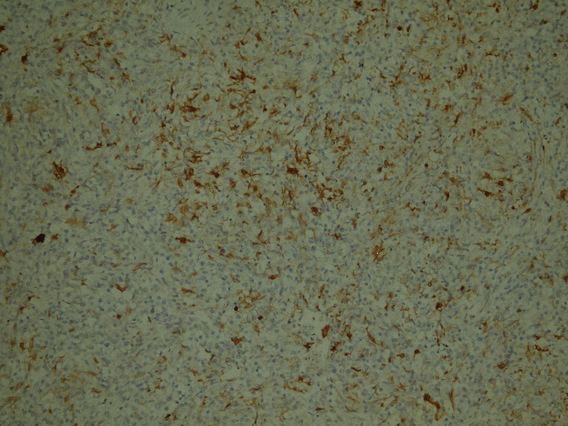
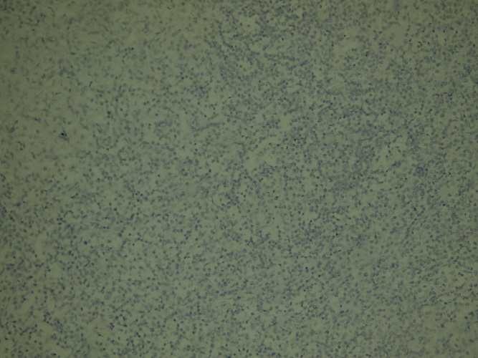
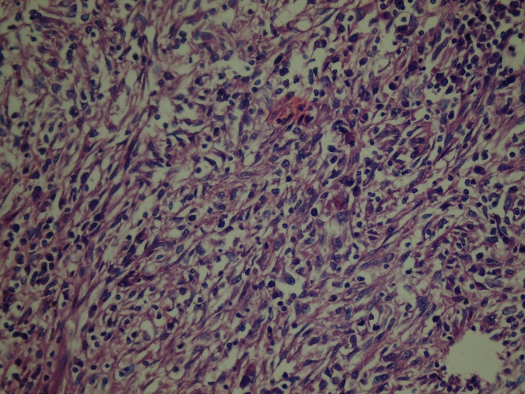
Core biopsy taken from inguinal lymph nodes showed lymph nodes filled with epithelioid granuloma and mixed inflammatory cells (lymphocytes, plasma cells and histiocytes). One month later, a repeated excisional biopsy was taken from cervical lymph nodes which showed, marked infiltration of the lymph node by lymphocytes, plasma cells, and histiocytes that are identified through Hematoxylin and eosin stain (H&E). Further immune histochemistry (IHC), these cells are positive for CD3 and CD20 but not for CD30 and CD15. At this stage, the patient was considered to have sinus histiocytosis (ROSAI-DORFMAN disease) and treated with low doses of steroids.
Figure 2: S100 positive staining of IDCS
Figure 3: CD1a negative staining excluding follicular dendritic cell sarcoma
Figure 1: H%E staining of IDCS showing a section of an affected lymph nodes
Despite that, the lymphadenopathy becomes progressive, thus, a new excisional biopsy was taken from left axillary lymph node which showed atypical lymphoid proliferation composed of medium-sized lymphocytes. Further IHC, the cells are positive for S100 and CD68, negative for CD3, 20, 21, 23, 15, 30 and 1a. This IHC pattern favoured the diagnosis of dendritic cell sarcoma. Bone marrow aspiration was within normal limits.
After the establishment of the correct diagnosis, we started him CHOP-21 regimen (Intravenous cyclophosphamide 750mg/m²/D1, Intravenous doxorubicin 50mg/m²/D1, vincristine 2mg/D1, oral prednisone 100mg/D1-5) for a total of six cycles with interim assessment after the third one which supports responsiveness of the disease to the selected regimen.
Following the sixth cycle, nearly all bulky lymph nodes are remitted to normal size except small inguinal and cervical which were less than 2 cm in diameter. Positron emission tomography scan revealed no FDG activity of these residual lymph nodes. Thus, we put the patient on close follow up every two months by clinical examination and labs while CT imaging is to be done whenever necessary.
Seven months later, the patient developed progressive lymphadenopathy again; definite relapse. We started him ESHAP (I.V Etoposide 40mg/m2/D1-4, I.V methylprednisolone 500 mg D1-5, I.V Cisplatin 25mg/m2 D1-4, I.V cytarabine 2000 mg/m2 D5) for 2 cycles. Currently, the patient received only one cycle of this regimen.

Discussion
Interdigitating dendritic cell sarcoma is a very rare malignant tumour arising from the dendritic cells that are located within the T-cell rich area of the lymph node. [3, 23] Clinically, the disease usually appears as progressive lymph node enlargement, especially in cervical, mediastinal and axillary area. The median age of diagnosis is between 50 and 60 years of age with an almost equal male to female ratio. [3, 11, 23]
Pathological identification of this disease requires the use of IHC panels beside the traditional H&E staining. IDCS appears in picture simulating lymphoma with dense infiltration plasma cells and histiocytes. Although IDCS cells are usually CD68, S100 positive and CD20, 5, 50,21, 23 negatives, there aren’t any specific marker for identifying and diagnosis of IDCS has been identified [8, 10]
Still, the literature lacks any explanatory mechanism with regards the genetic drivers and progenitors of this neoplasm, however, several authors suggested that malignant transformation of CD34 positive epidermal Langerhans cells, CD14 positive myeloid cells in the bone marrow or CD4 positive/CD11 negative lymphoid cells in the thymus may be the cell of origin for these tumours. {Nakamura, 1989 #27}
Till now, there is no consensus among best therapeutic approach and the appropriate chemotherapeutic agent this disease. [11, 20, 23]
In this review, we present a case of a middle-aged man who complained of progressive lymphadenopathy. Initial biopsy and pathological examination failed to diagnose the condition, however, a later biopsy from his axillary lymph nodes followed by H&E and IHC examination succeeded to diagnose the condition. He was subjected to the classic CHOP-21 regimen for a total of 6 cycles. Interim and post-therapy assessment by CT imaging and PET CT confirmed the responsiveness of the patient and achievement of complete remission. As expected from this disease, seven months later, he has a proved relapse in his cervical, axillary and inguinal lymph nodes. Now, he is enrolled in a trial of ESHAP.

Conclusion
Interdigitating dendritic cell sarcoma is a very rare neoplasm arising from dendritic cells within the lymph nodes. It is characterized by high recurrence and poor responsiveness to treatment.
In the current practice, there are several limitations in dealing with IDCS patients. First, no consensus among best approach for pathological review of the specimens. Second, the lack of homogeneity in selecting chemotherapeutic regimens and finally, the high rate of recurrence either local or distant indicate need to identify appropriate new therapies.

Acknowledgement
The authors have no acknowledgement regarding this manuscript.

AUTHORS’ DISCLOSURES OF POTENTIAL CONFLICTS OF INTEREST
The author(s) indicated no potential conflicts of interest.

Reference
1. Fonseca R, Y.M., Nakamura S, et al. , Follicular dendritic cell sarcoma and interdigitating reticulum cell sarcoma: a review. Am J Hematol 1998;59:161-7.
2. Kairouz S, H.J., Kabbara W, McHayleh W, Tabbara IA, Dendritic cell neoplasms: an overview. . Am J Hematol 2007;82:924-8.
3. Swerdlow, S.H., et al., The 2016 revision of the World Health Organization classification of lymphoid neoplasms. Blood, 2016. 127(20): p. 2375-90.
4. Ye Z1, L.F., Cao Q, Lin H., Interdigitating dendritic cell sarcoma of Lymph node mimicking Granuloma: a case report and review of the literature. Pol J Pathol. 2011 Dec;62(4):274-7.
5. Hiroya Ohtake, M.Y., interdigitating dendritic cell sarcoma and follicular dendritic cell sarcoma: histopathological findings for differential diagnosis. J Clin Exp Hematop vol. 53 No. 3, Dec 2013.
6. Kawachi K, N.Y., Inayama Y, Kawano N, Toda N, Misugi K Interdigitating dendritic cell sarcoma of the spleen : report of a case with a review of the literature. . Am J Surg Pathol 2002;26:530-7.
7. Luk IS, S.T., Tang VW, Ng WF, Interdigitating dendritic cell tumor of the testis: a novel testicular spindle cell neoplasm. Am J Surg Pathol 1999;23:1141-8.
8. Steinman, R.M., M. Pack, and K. Inaba, Dendritic cells in the T-cell areas of lymphoid organs. Immunol Rev, 1997. 156: p. 25-37.
9. Li, L., et al., Clinicopathological features and prognosis assessment of extranodal follicular dendritic cell sarcoma. World J Gastroenterol, 2010. 16(20): p. 2504-19.
10. Pileri, S.A., et al., Tumours of histiocytes and accessory dendritic cells: an immunohistochemical approach to classification from the International Lymphoma Study Group based on 61 cases. Histopathology, 2002. 41(1): p. 1-29.
11. Saygin, C., et al., Dendritic cell sarcoma: a pooled analysis including 462 cases with presentation of our case series. Crit Rev Oncol Hematol, 2013. 88(2): p. 253-71.
12. Mao, R.J., et al., [Granuloma-like interdigitating dendritic cell sarcoma: report of a case]. Zhonghua Bing Li Xue Za Zhi, 2012. 41(2): p. 134-6.
13. Gaertner EM, T.M., Derringer GA, Neuhauser TS, Arciero C, Andriko JA. , Interdigitating dendritic cell sarcoma. A report of four cases and review of the literature. . Am J Clin Pathol 2001;115:589-97.
14. Rosenberg, S.A., et al., Interdigitating dendritic cell sarcoma presenting in the skin: diagnosis and the role of surgical resection, chemotherapy and radiotherapy in management. Rare Tumors, 2014. 6(4): p. 5573.
15. Zhu, J., et al., Interdigitating dendritic cell sarcoma presenting in the sigmoid colon mesentery: A case report and literature review. Medicine (Baltimore), 2017. 96(16): p. e6210.
16. Perkins, S.M. and E.T. Shinohara, Interdigitating and follicular dendritic cell sarcomas: a SEER analysis. Am J Clin Oncol, 2013. 36(4): p. 395-8.
17. Gounder, M., et al., Impact of surgery, radiation and systemic therapy on the outcomes of patients with dendritic cell and histiocytic sarcomas. Eur J Cancer, 2015. 51(16): p. 2413-22.
18. Cossu, A., et al., Synchronous interdigitating dendritic cell sarcoma and B-cell small lymphocytic lymphoma in a lymph node. Arch Pathol Lab Med, 2006. 130(4): p. 544-7.
19. Fraser, C.R., et al., Transformation of chronic lymphocytic leukemia/small lymphocytic lymphoma to interdigitating dendritic cell sarcoma: evidence for transdifferentiation of the lymphoma clone. Am J Clin Pathol, 2009. 132(6): p. 928-39.
20. Gaertner, E.M., et al., Interdigitating dendritic cell sarcoma. A report of four cases and review of the literature. Am J Clin Pathol, 2001. 115(4): p. 589-97.
21. Bani, D., et al., Interdigitating reticulum cells in the dermal infiltrate of mycosis fungoides. An ultrastructural and immunohistochemical study. Virchows Arch A Pathol Anat Histopathol, 1988. 412(5): p. 451-8.
22. Poblete, M.T., C.D. Figueroa, and I. Caorsi, Ultrastructural characteristics of the interdigitating dendritic cell in dermatopathic lymphadenopathy of mycosis fungoides patients. J Pathol, 1987. 151(4): p. 263-9.
23. Kairouz, S., et al., Dendritic cell neoplasms: an overview. Am J Hematol, 2007. 82(10): p. 924-8.

